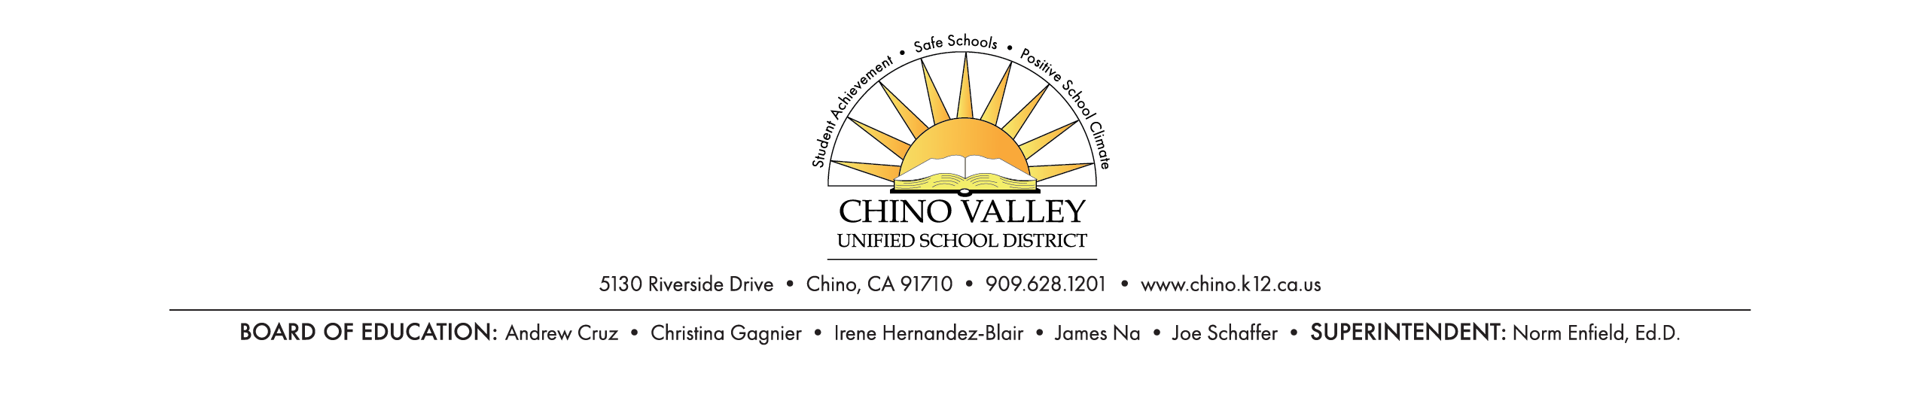

**Health and Developmental History**

Student Name __________________________________________ Date of birth _______________________

School _____________________________ Grade________ Teacher/Counselor ________________________

1. Were there any medical concerns during pregnancy Yes No.

If yes, please explain ________________________________________________________________

1. Were there any medical concerns during the birthing process? Yes No

If yes, please explain_________________________________________________________________

1. Were there any medical concerns during the student’s early development? Yes No

If yes, please explain _________________________________________________________________

1. Vision No problems Wears glasses Eye surgery details_________________________________

When was the last vision test done? ____________________________________________________

1. Hearing No problem Hearing aids Tubes/other surgery Other issues ____________________

When was the last hearing test done? ___________________________________________________

1. When was your student’s last physical exam? _____________________________________________
2. Is your student being currently being followed by a doctor for any medical/emotional concern(s)? Yes No If yes, please explain _____________________________________________________________
3. When was your student’s last dental exam? ___________ Any concerns? Yes No

If yes, please explain ________________________________________________________________

1. Please list your student’s medical/behavioral/emotional concerns _____________________________ __________________________________________________________________________________
2. Any serious illnesses or hospitalizations?_________________________________________________
3. Does your student have any allergies to anything? __________________________________________
4. What medications is your student currently taking? ________________________________________

____________________________________________________________________________________

13. Is there any history of family members having difficulty in school? ____________________________

14. Are there any concerns about your student’s sleeping habits? _________________________________

15. Are there any concerns about your student’s eating habits? ___________________________________

Parent Printed Name _____________________________ Signature __________________________________

Date __________________ Best contact number ________________________________________________

REV 5/20